**Hardware Design**

1. **Schematic design**
2. **Overall system**

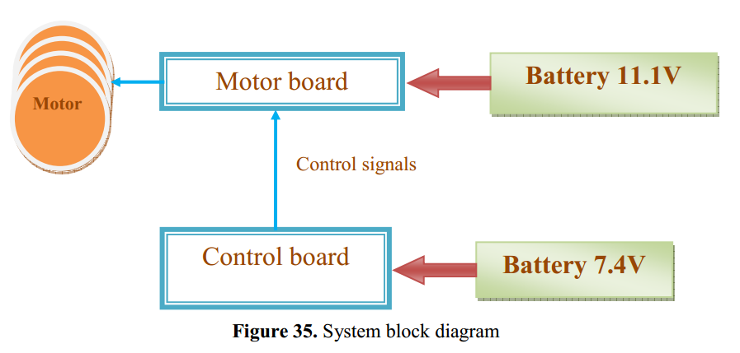

The system has been broken into two distinct parts: Motor board and control board. Motors require high current during operation, it is probably necessary to separate two power supply for motors and control circuit board to ensure the properly function of FPGA chip.

1. **The motor board**

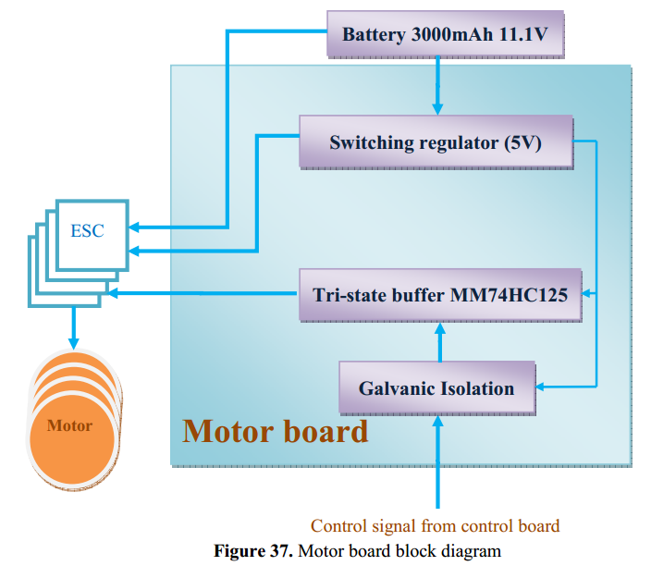

Control signals from FPGA are not directly control motors. They are isolated and buffered by tri-state MM74HC125.

1. **Control board (FPGA)**

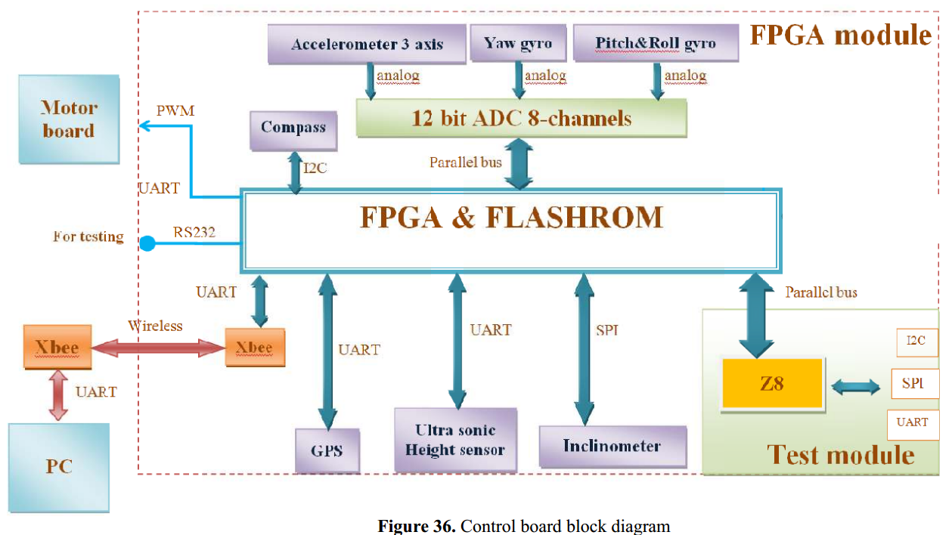

The control board has two processing unit: 1 FPGA chip (Spartan-3 from Xilinx) and a micro controller (Z8F6423 from Zilog)

* FPGA: it interfaces to all digital and analogue sensors. The PID controller is also implemented on FPGA
* Z8 uC : it is used as a test module. It provides standard interfaces such as SPI, I2C, UART and analogue input channels. It is useful to test sensors and PID control algorithm.

Sensors with both digital and analogue output are used in the design. An ADC (Analogue to Digital Converter 12 bit is used to interface with analogue sensors)

1. **Implementation of schematic design**

This part specifies the selection of electronic devices on the final boards. There is a separate excel file to list all electronic parts and suppliers of them.

1. **Power supply**

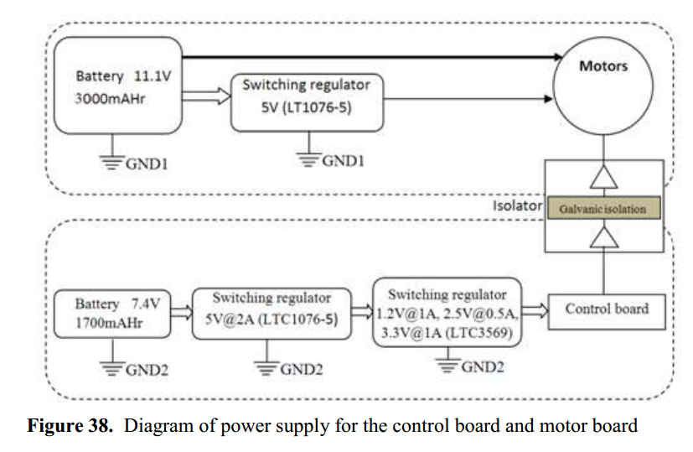

The digital isolator from Avero is used to isolate ground references between motor board and control board. Moreover, another tri-state buffer MM74HC125from Fairchild Semiconductor is used to interface between opto-coupler with motors to drive motor control signals.

The switching regulators are selected based on power need of boards.

|  |  |  |  |  |
| --- | --- | --- | --- | --- |
| Supply voltage | Sections used | Max current required | Total | Provided |
| 5V | Short range sensor | 50 mA | 1188mA | 2000mA |
| ADC7938 | 3mA |
| ADXRS613 – yaw gyroscope | 5 mA |
|  | 1.2V,2.5V, 3.3V supply | 1130 mA |
|  | | | | |
| 3.3V | Inclinometer ADIS16209 | 42 mA | 702 mA | 1000mA |
|  | Xbee wireless transceiver | 10mA |
|  | Z8 microcontroller | 150 mA |
|  | FPGA I/O supply VCCO | 500mA |
|  | | | | |
| 2.5V | FPGA auxiliary supply voltage VCCAUX | 500mA | 500mA | 500mA |
|  | | | | |
| 1.2V | FPGA internal supply voltage VCCINT | 300mA | 300mA | 1000mA |

Power budget summary

List of electronic devices for power supply

* LT1076-5 : output 5V , 2 A max
* LTC3569 : output 3 different range [1.2V@1A](mailto:1.2V@1A), [2.5V@0.5A](mailto:2.5V@0.5A), [3.3V@1A](mailto:3.3V@1A)
* Digital isolator Avero : ????
* Tri-state buffer MM74HC125 from Fairchild
* Battery : LiPo [7.4V@1700AHr](mailto:7.4V@1700AHr) and LiPo [11.1V@3000AHr](mailto:11.1V@3000AHr)

1. **Sensors and ADC** 
   1. **Accelerator**
   2. **Inclinometer**
   3. **Gyroscope**
   4. **Sonar ranger**
   5. **Compass**
   6. **ADC**

It provides an interface between FPGA chip and analogue sensors. The datawidth of 12 bits is used to interface with FPGA

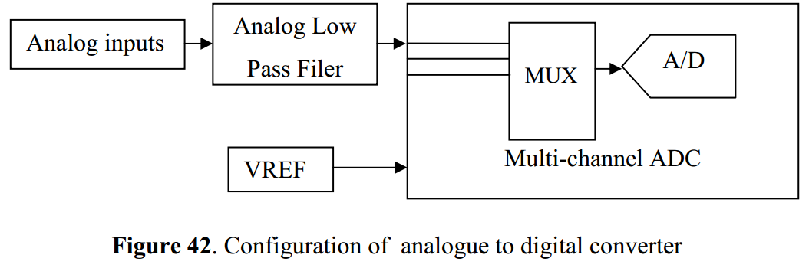

The requirements for ADC are based on the analogue inputs from sensors as the following table

|  |  |  |  |
| --- | --- | --- | --- |
| Sensor | Dynamic | range | Sensitivity |
| Accelerometer | 0.5-3V | +/-3.6g | 330mV/g |
| Pitch and Roll gyroscopes  IDG-500 | 0.5 – 4.5V | +/-1100/s | 9.1 mV/0/s |
| Yaw gyroscope ADXRS613 | 0.5 – 3.3V | +/-1500/s | 13.75 mV/0/s |

The ADC7938-6 from Analog Devices [37] was selected to implement in the design. It is a 12 bits ADC which offers sufficiently resolution for reading all sensors on the table above

This ADC uses a voltage reference of 2.5 but it can sample input signals up to double of its reference voltage. Moreover, it can sample inputs at a maximum rate of 625 ksps and this rate can be adjusted. The data output is in form of straight binary. Moreover, it has driven voltage feature to flexibly interface with other devices operating with different voltage supply. Hence, it can be directly interfaced with FPGA by connecting the driven voltage pin of ADC chip to 3.3V

1. **Processing Unit**
2. **Motors**

Brushless Motor R2810 900KV

Propeller of 10 x5

ESC – update later

It is not sure that the motor and ESC is suitable for the quadcopter or not because PID controllers is still developing. Maybe rapid ESC with higher refresh rates is required.

**Final version of Quad-copter**

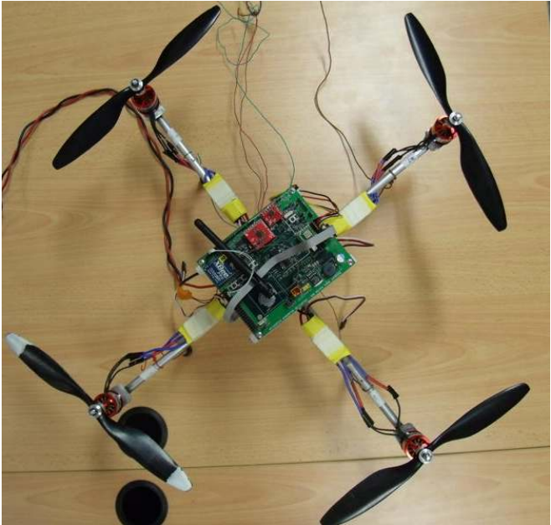

**The test jig**

It used to test the system balance with two motors.

